Title
by

Your Name
A Thesis/Dissertation
Submitted to the
Graduate Faculty
of
George Mason University
in Partial Fulfillment of
The Requirements for the Degree
of
Name of Degree, such as Master of Science or Doctor of Philosophy
Academic Discipline for Degree—DO NOT include concentration

Committee:

READ THIS SECTION BEFORE MAKING ANY CHANGES TO IT.
Signature Sheet templates for all colleges and schools (and for degrees/disciplines within the colleges/schools) can be found here:
https://udts.gmu.edu/signature-sheets/
After you have chosen the appropriate Signature Sheet template for your college/school/discipline, please copy the text under “Committee:” on that template.
Paste the copied text under “Committee:” here on this page. The new text should replace this text.
If your discipline’s Signature Sheet template does not have any names, real or fake (i.e., Dr. Abcdef Ghijkl,), next to the signature lines under “Committee:”, DO NOT supply names here. This rule applies to the College of Education and Human Development, the College of Humanities and Social Sciences, the College of Visual and Performing Arts, and the School for Conflict Analysis and Resolution.
If your discipline’s Signature Sheet template DOES have names, real or fake, replace those names with the appropriate information.

Title
A Thesis/Dissertation submitted in partial fulfillment of the requirements for the degree of Name of Degree, such as Master of Science or Doctor of Philosophy at George Mason University
by
Your Name
Most Recently Earned Degree – Do Not Include Discipline/Concentration
School from Which You Earned Last Degree, Year You Earned It
Previously Earned Degree – Do Not Include Discipline/Concentration
School from Which You Earned Previous Degree, Year You Earned It
Director: Name of the Head of Your Committee, Committee Head’s Job Title
Committee Head’s Specific Affiliation – DO NOT say “George Mason University”
Season Semester Year
George Mason University
Fairfax, VA

Copyright 2026 Your Name
All Rights Reserved
Dedication
I dedicate this work to . . .
Acknowledgements
I wish to thank my advisor, Dr. Margaret Gunderson, for her guidance and support throughout this process. I also want to thank the members of my committee for their invaluable input and infinite patience: Dr. Harold Goldfarb, Dr. Marian Silver, and Dr. Sara Love-Rabinowitz. Finally, my work would not have been possible without generous grants from the Tyrell Corporation, Renholm Industries, Price & Price, and the Weyland-Yutani Corporation.

Table of Contents
Page
List of Tables vi
List of Figures vii
List of Equations viii
List of Abbreviations and/or Symbols ix
Abstract x
Chapter One 1
This Is an Example of a Section Heading 2
Another Section Heading 3
A Subsection Heading 4
A Sub-Subsection Heading 5
An Inset Heading 6
Subsection 6
Another Sub-subsection 6
Chapter Two 7
Subsection 8
Another Subsection 9
Another Section 10
Chapter Three 11
Chapter Four 12
Chapter Five 13
Chapter Six 14
Appendix 15
References 16

List of Tables
Table Page
Table 1: You are permitted to use color in Tables and Figures. We inserted a Page Break before this caption to prevent it from breaking awkwardly between pages. That is an optional step, and you are not required to do it. Please see Table 3 to see the result of NOT inserting a Page Break. 2
Table 2: You may have an image of a Table. An image of a Table is still a Table and should be labeled and listed as such. 5
Table 3: Tables can break between pages, but if you would prefer to insert a Page Break above the caption for the Table, so that the Table always starts at the top of the next page, you can. 7

List of Figures
Figure Page
Figure 1: An example of a library. Please note that Tables and Figures (and their accompanying captions) must be separated from nearby lines of body text by at least 3 single-spaced blank lines above and below. You may have more space, but you may not have less. 3
Figure 2: A construction site. Your captions can be as long as you wish, but you do not have to include all of the caption’s text in the List of Tables or List of Figures (although you are welcome to do so if you wish). If you need assistance with this issue, please contact the UDTS Coordinator: udts@gmu.edu. 9

List of Equations
Equation Page
Equation 1 4
Equation 2 4
3 4
4 4
Equation 5 4
Equation 6 4

List of Abbreviations and/or Symbols
Euro €
Her Majesty's Stationery Office HMSO
Measuring Usability of Systems in Context MUSiC
Pi Π
Royal National Institute for the Blind RNIB
United Kingdom UK

Abstract
Title
Your Name, Choose an item.
George Mason University, 2026
Thesis/Dissertation Director: Dr. Name of the Head of Your Committee

A brief yet comprehensive general abstract for the entire document is required to frame the manuscripts and their related conceptual foundations, methodological stream and/or commonalities in addressing a problem or phenomena. The general abstract will help the reader understand the intent of the broader study(ies), as well as the theoretical frameworks, phenomena and methods. The abstract might also describe the participants or contexts that guide the dissertation and all manuscripts, as well as an overview of the results, findings, conclusions and implications. Each component manuscript also will have an abstract that includes the manuscript-specific problem, methodologies, conclusions, and implications.

Chapter One
All material in the document must adhere to University Formatting Guidelines. For questions and further information, please contact the UDTS Coordinator: udts@gmu.edu.
All text in the document must be black, and it must be readable, but you are welcome to change the way all of the text looks. For example: the fact that the Heading 2 Style is Left-Justified 12Pt Bold Small Caps Times New Roman is completely arbitrary. You can either center or left-justify Headings 2 – 9; you can set them in ALL CAPS, Small Caps, or Title Caps; they can be any size, as long as that size is readable; they can be any font. The appearance of your material is up to your personal preference, or it can match the citation guidelines (e.g., APA, MLA, Chicago, etc.) you are using.

Table 1: You are permitted to use color in Tables and Figures. We inserted a Page Break before this caption to prevent it from breaking awkwardly between pages. That is an optional step, and you are not required to do it. Please see Table 3 to see the result of NOT inserting a Page Break.

This Is an Example of a Section Heading
You can also make adjustments to the Body Text style. Currently, Body Text is set at ragged right, with a first-line indent. You may change the Body Text’s font; you may remove the first-line indent; you may fully justify the Body Text. Body text must remain double-spaced, with the following caveats:
Block Quotes: If you are using a style that requires block quotes to be single-spaced, you are permitted to make that change. We have provided a style for that: Block.

You may also single-space numbered lists and bulleted lists. They can be single-spaced if you wish.

Another Section Heading
Students are welcome to include Tables and Figures in the manuscript. They can be interspersed throughout the manuscript body, grouped at the end of the manuscript’s body, or placed in the Appendix specific to this manuscript.


Figure 1: An example of a library. Please note that Tables and Figures (and their accompanying captions) must be separated from nearby lines of body text by at least 3 single-spaced blank lines above and below. You may have more space, but you may not have less.

The default numbering convention for Tables and Figures here in the Traditional (Chapter-Based) Template is consecutive (i.e., if there are 50 Tables in the body of the document, then the first one is Table 1 and the last one is Table 50). If you would like to number the Tables and Figures according to the chapter that they are in (e.g., in Chapter 2, you have Table 2.1, Table 2.2, and Table 2.3; in Chapter 4, you have Figure 4.1, Figure 4.2, and Figure 4.3), please contact the UDTS Coordinator for assistance: udts@gmu.edu.

A Subsection Heading

Equations are not bound by the same rules as Tables and Figures. You are not required to include a List of Equations, even if you have Equations in the body of the document. Equations also are not bound by the same spacing rules as Tables and Figures; you can have as much or as little space above and/or below Equations as you wish. Furthermore, captions for Equations work differently. They can consist only of a label (e.g., “Equation 2.1”) or a number (e.g., “2.1”). Finally, captions can be placed above, below, or to the right of Equations. For example:
Equation 1
$${\left(x+a\right)}^{n}=\sum_{k=0}^{n}{\left({n \atop k}\right)x^{k}a^{n-k}}$$

$${\left(1+x\right)}^{n}=1+\frac{nx}{1!}+\frac{n\left(n-1\right)x^{2}}{2!}+…$$
Equation 2

3
$$A=πr^{2}$$

$$f\left(x\right)=a_{0}+\sum_{n=1}^{∞}{\left(a_{n}\cos{\frac{nπx}{L}}+b_{n}\sin{\frac{nπx}{L}}\right)}$$
4

$$\text{r}=\frac{1}{2}\text{a}t^{2}+{\text{v}}_{\text{o}}t+{\text{r}}_{\text{0}}$$ | Equation 5

$$A = P{\left.\left(1 + \frac{r}{n}\right.\right)}^{nt}$$ | Equation 6

A Sub-Subsection Heading
A bunch of text that says something profound will soon appear here. A bunch of text that says something profound will soon appear in this document. A bunch of text that says something profound will soon appear in this document. A bunch of text that says something profound will soon appear in this document. A bunch of text that says something profound will soon appear in this document.

Table 2: You may have an image of a Table. An image of a Table is still a Table and should be labeled and listed as such.
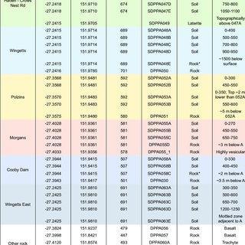
Note: From https://www.researchgate.net/publication/362277971_Geochemistry_of_rocks_and_soils_associated_with_the_Cooby_Trachyte_Member_in_the_Crows_Nest_region_southeast_Queensland

An Inset Heading. You are welcome to have an inset heading (or subheading, or sub-subheading, etc.) That means that the heading would begin on the same line with the first sentence in the paragraph, as this one does. It can be at any level between Heading 2 and Heading 9.
A bunch of text that says something profound will soon appear here. A bunch of text that says something profound will soon appear in this document. A bunch of text that says something profound will soon appear in this document. A bunch of text that says something profound will soon appear in this document. A bunch of text that says something profound will soon appear in this document.

Subsection
A bunch of text that says something profound will soon appear here. A bunch of text that says something profound will soon appear in this document. A bunch of text that says something profound will soon appear in this document. A bunch of text that says something profound will soon appear in this document. A bunch of text that says something profound will soon appear in this document.

Another Sub-subsection
A bunch of text that says something profound will soon appear here. A bunch of text that says something profound will soon appear in this document. A bunch of text that says something profound will soon appear in this document. A bunch of text that says something profound will soon appear in this document. A bunch of text that says something profound will soon appear in this document.

Chapter Two
A bunch of text that says something profound will soon appear here. A bunch of text that says something profound will soon appear in this document. A bunch of text that says something profound will soon appear in this document. A bunch of text that says something profound will soon appear in this document. A bunch of text that says something profound will soon appear in this document.
A bunch of text that says something profound will soon appear here. A bunch of text that says something profound will soon appear in this document. A bunch of text that says something profound will soon appear in this document. A bunch of text that says something profound will soon appear in this document. A bunch of text that says something profound will soon appear in this document.

Table 3: Tables can break between pages, but if you would prefer to insert a Page Break above the caption for the Table, so that the Table always starts at the top of the next page, you can.
Psych | 11/11/2022 | 1/18/2023 | Yes | 1/16/2023 | 11/22/2022
Edu | 12/2/2022 | 1/6/2023 | Yes | 1/5/2023 | 1/6/2023
ESPP | 8/18/2022 | 8/29/2022 | Yes | 8/17/2022 | 8/29/2022
Edu | 11/7/2022 | 11/18/2022 | Yes | 11/16/2022 | 11/18/2022
PubPol | 11/18/2022 | 11/22/2022 | Yes
Edu | 1/23/2023 | 1/31/2023 | Yes
BioEng | 12/5/2022 | 1/6/2023 | Yes | 12/9/2022 | 1/6/2023
BioInfo | 10/14/2022 | 1/6/2023 | Yes | 12/14/2022
PubPol | 1/17/2023 | 1/19/2023 | Yes | 1/19/2023 | 1/19/2023
CSI | 1/3/2023 | 1/13/2023 | Yes | 1/10/2023 | 1/13/2023
Bio | 10/20/2022 | 11/30/2022 | Yes | 1/3/2022 | 11/30/2022
BioSci | 1/9/2023 | 1/13/2023 | Yes
PubPol | 4/19/2022 | 4/27/2022 | Yes | 4/25/2022 | 4/27/2022
Bio | 11/21/2022 | 11/27/2022 | Yes
IT | 11/22/2022 | 1/19/2023 | Yes | 1/17/2023 | 1/13/2023
ESP | 11/28/2022 | 1/20/2023 | Yes | 1/20/2023 | 1/20/2023
CAR | 1/24/2023 | 1/31/2023 | Yes
BioInfo | 10/20/2022 | 11/30/2022 | Yes | 11/29/2022 | 11/30/2022

Subsection
A bunch of text that says something profound will soon appear here. A bunch of text that says something profound will soon appear in this document. A bunch of text that says something profound will soon appear in this document. A bunch of text that says something profound will soon appear in this document. A bunch of text that says something profound will soon appear in this document.

Another Subsection
A bunch of text that says something profound will soon appear here. A bunch of text that says something profound will soon appear in this document. A bunch of text that says something profound will soon appear in this document. A bunch of text that says something profound will soon appear in this document. A bunch of text that says something profound will soon appear in this document.

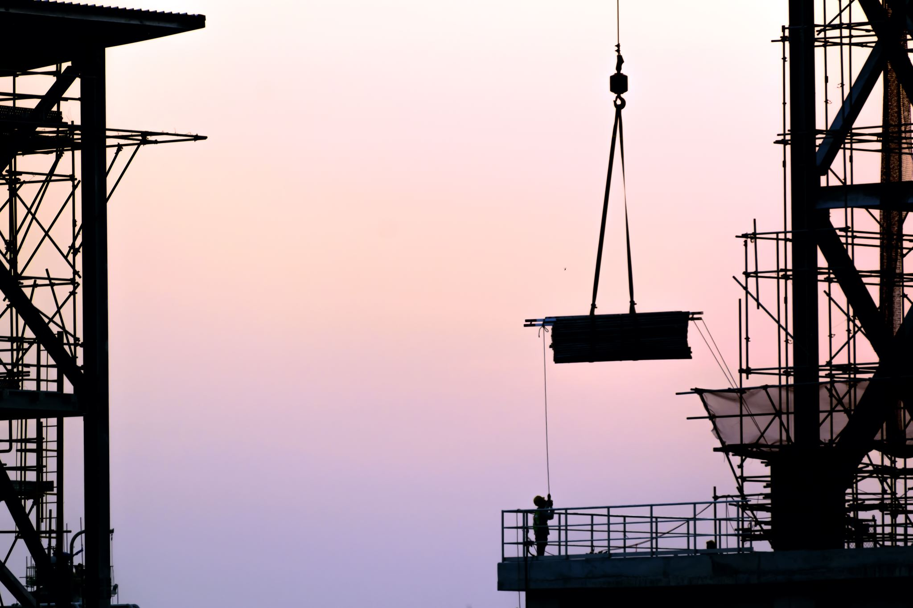
Figure 2: A construction site. Your captions can be as long as you wish, but you do not have to include all of the caption’s text in the List of Tables or List of Figures (although you are welcome to do so if you wish). If you need assistance with this issue, please contact the UDTS Coordinator: udts@gmu.edu.

Another Section
A bunch of text that says something profound will soon appear here. A bunch of text that says something profound will soon appear in this document. A bunch of text that says something profound will soon appear in this document. A bunch of text that says something profound will soon appear in this document. A bunch of text that says something profound will soon appear in this document.

Chapter Three
A bunch of text that says something profound will soon appear here. A bunch of text that says something profound will soon appear in this document. A bunch of text that says something profound will soon appear in this document. A bunch of text that says something profound will soon appear in this document. A bunch of text that says something profound will soon appear in this document.

Chapter Four
A bunch of text that says something profound will soon appear here. A bunch of text that says something profound will soon appear in this document. A bunch of text that says something profound will soon appear in this document. A bunch of text that says something profound will soon appear in this document. A bunch of text that says something profound will soon appear in this document.

Chapter Five
A bunch of text that says something profound will soon appear here. A bunch of text that says something profound will soon appear in this document. A bunch of text that says something profound will soon appear in this document. A bunch of text that says something profound will soon appear in this document. A bunch of text that says something profound will soon appear in this document.

Chapter Six
A bunch of text that says something profound will soon appear here. A bunch of text that says something profound will soon appear in this document. A bunch of text that says something profound will soon appear in this document. A bunch of text that says something profound will soon appear in this document. A bunch of text that says something profound will soon appear in this document.

Appendix
An Appendix is not required. You are welcome to include one, if you wish.

References
Arestis, P., & Sawyer, M. C. (2010). 21st Century Keynesian Economics. Houndsmills, Basingstoke, Hampshire: Palgrave Macmillan.

Holcombe, R. G. (Ed.). (1999). 15 Great Austrian Economists. Auburn, Ala: Ludwig von Mises Institute.

Klaver, C. C. (2003). A/Moral Economics: Classical Political Economy and Cultural Authority in Nineteenth-Century England. Columbus: Ohio State University Press.

Tilly, R. H., Welfens, P. J. J., & Heise, M. (2007). 50 Years of EU Economic Dynamics: Integration, Financial Markets, and Innovations. Berlin: Springer.

Biography
Your Name received her Bachelor of Arts in Sociology from Louisiana State University in 2011, then went on to Boston College to receive her Master of Science in Biology. After receiving her Doctor of Philosophy in Public Policy from George Mason University in 2023, she will continue to work for the federal government.

