Title
by

Your Name
A Thesis/Dissertation
Submitted to the
Graduate Faculty
of
George Mason University
in Partial Fulfillment of
The Requirements for the Degree
of
Name of Degree, such as Master of Science or Doctor of Philosophy
Academic Discipline for Degree—DO NOT include concentration

Committee:

READ THIS SECTION BEFORE MAKING ANY CHANGES TO IT.
Signature Sheet templates for all colleges and schools can be found here: https://udts.gmu.edu/signature-sheets/.
After you have chosen the appropriate Signature Sheet template for your college/school/discipline, please copy the text under “Committee:” on that template.
Paste the copied text under “Committee:” here on this page. The new text should replace this text.
If your discipline’s Signature Sheet template does not have any names, real or fake (i.e., Dr. Abcdef Ghijkl), next to the signature lines under “Committee:”, DO NOT supply names here. This rule applies to the College of Education and Human Development, the College of Humanities and Social Sciences, the College of Visual and Performing Arts, and the School for Conflict Analysis and Resolution.
If your discipline’s Signature Sheet template DOES have names, real or fake, replace those names with the appropriate information.
Title
A Thesis/Dissertation submitted in partial fulfillment of the requirements for the degree of Name of Degree, such as Master of Science or Doctor of Philosophy at George Mason University
by
Your Name
Most Recently Earned Degree – Do Not Include Discipline/Concentration
School from Which You Earned Last Degree, Year You Earned It
Previously Earned Degree – Do Not Include Discipline/Concentration
School from Which You Earned Previous Degree, Year You Earned It
Director: Name of the Head of Your Committee, Committee Head’s Job Title
Committee Head’s Specific Affiliation – NOT “George Mason University”
Season Semester Year
George Mason University
Fairfax, VA

Copyright 2026 Your Name
All Rights Reserved
Dedication
I dedicate this work to my beloved Nova Scotia Duck-Tolling Retriever, Admiral Butterbean Picklepants. I could not have done this without her, and I am forever indebted to her for her eternal love and unceasing support.
My family members are also perfectly fine.
Acknowledgments
I wish to thank my advisor, Dr. Margaret Gunderson, for her guidance and support throughout this process.
I also want to thank the members of my committee, Dr. Nick Riviera and Dr. Tobias Fünke, for their invaluable input and infinite patience.
Finally, my work would not have been possible without generous grants from Renholm Industries, Price & Price, and the Weyland-Yutani Corporation.
Disclaimer
This is an optional page that can be used if you need to include a disclaimer or statement about material included in your document.
Statement of AI Usage
This is an optional page that can be included if you used AI to create any material in your document and you wish to make future readers aware of its usage.
Notification of Author’s Previously Published Material
This is an optional page that can be included if your document includes your own previously published material and you want to make future readers aware of its existence.

Table of Contents
Page
List of Tables ix
List of Figures x
List of Equations xi
List of Abbreviations xii
List of Symbols xiii
Abstract xiv
Chapter Title 1
A Section 1
Chapter Title 4
A Subsection 6
Another Subsection 7
A sub-subsection 8
A sub-sub-subsection 8
Chapter Title 10
A Section 11
A Subsection 11
A Sub-Subsection. 12
Chapter Title 14
Appendices 16
References/Bibliography/Works Cited 17

List of Tables
Table Page
Table 1: You are welcome to include Tables and Figures throughout your document. All Tables must have header rows. 2
Table 2: We inserted a Page Break before the caption to prevent the Table from breaking awkwardly between pages. That is an optional step, and you are not required to do it. Please see Tables 3 and 4 to see the result of NOT inserting a Page Break. If you need assistance with this issue, please contact the UDTS Coordinator: udts@gmu.edu. All Tables must have header rows. 5
Table 3: You are permitted to use color in Tables and Figures. Your captions can be as long as you wish, but you do not have to include all of the caption’s text in the List of Tables or List of Figures (although you are welcome to do so if you wish). All Tables must have header rows. 5
Table 4: This Table came from an Excel spreadsheet. There is no Page Break above the caption, but one could be inserted if you wish. All Tables must have header rows. 10
Table 5: We don’t have rules for spacing between series of Tables, series of Figures, or a mixed series of Tables and Figures. Spacing rules only apply to Tables and Figures in relation to body text. All Tables must have header rows. 15

List of Figures
Figure Page
Figure 1: As Table 1 stated, you are welcome to include Tables and Figures. All Figures must have Alt Text. 3
Figure 2: An example of a library. Please note that Tables and Figures (and their accompanying captions) must be separated from nearby lines of body text by at least 3 single-spaced blank lines above and below. You may have more space, but you may not have less. All Figures must have Alt Text. 7
Figure 3: A construction site. Your captions can be as long as you wish, but you do not have to include all of the caption’s text in the List of Tables or List of Figures (although you are welcome to do so if you wish). If you need assistance with this issue, please contact the UDTS Coordinator: udts@gmu.edu. All Figures must have Alt Text. 12
Figure 4: Tables and Figures can be centered, if you wish. All Figures must have Alt Text. 14

List of Equations
Equation Page
Equation 1: Captions for Equations can be above the Equation, below the Equation, or to the side of the Equation. To learn more about placing the caption to the side of the Equation, please set up an appointment with the UDTS Coordinator: https://gmu.libcal.com/appointments?u=6908. 9

List of Abbreviations
American Kennel Club AKC
Measuring Usability of Systems in Context MUSiC
National Aeronautics and Space Administration NASA
North Atlantic Treaty Organization NATO
Self-Contained Underwater Breathing Apparatus SCUBA
United Kingdom UK

OR

AKC American Kennel Club
MUSiC Measuring Usability of Systems in Context
NASA National Aeronautics and Space Administration
NATO North Atlantic Treaty Organization
SCUBA Self-Contained Underwater Breathing Apparatus
UK United Kingdom

List of Symbols
Ampersand &
Euro €
Omega Ω
Pi Π
Solidus /
Yen ¥

OR

& Ampersand
€ Euro
Ω Omega
Π Pi
/ Solidus
¥ Yen

Abstract
Title
Your Name
George Mason University, 2026
Thesis/Dissertation Director: Dr. Name of the Head of Your Committee

A brief yet comprehensive general abstract for the entire document is required to frame the manuscripts and their related conceptual foundations, methodological stream and/or commonalities in addressing a problem or phenomena. The general abstract will help the reader understand the intent of the broader study(ies), as well as the theoretical frameworks, phenomena and methods. The abstract might also describe the participants or contexts that guide the dissertation and all manuscripts, as well as an overview of the results, findings, conclusions and implications. Each component manuscript also will have an abstract that includes the manuscript-specific problem, methodologies, conclusions, and implications.

Chapter Title
All text in the document must be black, and it must be set in an accessible font. You may change the appearance of main headings, section headings, and so on if to adhere to your citation style (e.g., APA).
You may also make adjustments to the Body Text style. Currently, Body Text is set at ragged right, with a first-line indent. You may remove the first-line indent; to remain accessible, body text should not be fully justified.
Body text must remain spaced at 1.5, with the following caveats:
Block Quotes: If you are using a style that requires block quotes to be single-spaced, you are permitted to make that change. We have provided a style for that: Block.
You may also single-space numbered lists and bulleted lists.

A Section
You are welcome to include Tables and Figures in the document. They can be interspersed throughout the chapter, grouped at the end of the chapter, or grouped at the end of the body. Tables and Figures may contain color.
The numbering convention for Tables and Figures here in the Traditional (Chapter-Based) Template has been set fully consecutively (e.g., there are 50 Tables and 50 Figures in the body of the document; the first Table is Table 1, the first Figure is Figure 1, the last Table is Table 50, and the last Figure is Figure 50). If you would prefer the Tables and Figures to be numbered according to the chapter in which they are located (e.g., Table 1.1, Table 1.2 would be in Chapter One, Table 2.1, Figure 2.1, Figure 2.2, would be in Chapter Two, and so on), or if you would prefer to number the Tables and Figures with repeating consecutive numbering (i.e., in the first chapter, you have Tables 1, 2, 3, and 4; in the second chapter, you have Tables 1, 2, 3, and 4; and so on), please contact the UDTS Coordinator for assistance: udts@gmu.edu.

Table 1: You are welcome to include Tables and Figures throughout your document. All Tables must have header rows.
 | A | B | C | D | E | F
Lorem
Ipsum
Dolor
Sit
Amet

Lorem ipsum dolor sit amet, consectetuer adipiscing elit. Aenean commodo ligula eget dolor. Aenean massa. Cum sociis natoque penatibus et magnis dis parturient montes, nascetur ridiculus mus. Donec quam felis, ultricies nec, pellentesque eu, pretium quis, sem. Nulla consequat massa quis enim. Donec pede justo, fringilla vel, aliquet nec, vulputate eget, arcu. In enim justo, rhoncus ut, imperdiet a, venenatis vitae, justo. Nullam dictum felis eu pede mollis pretium. Integer tincidunt. Cras dapibus. Vivamus elementum semper nisi.

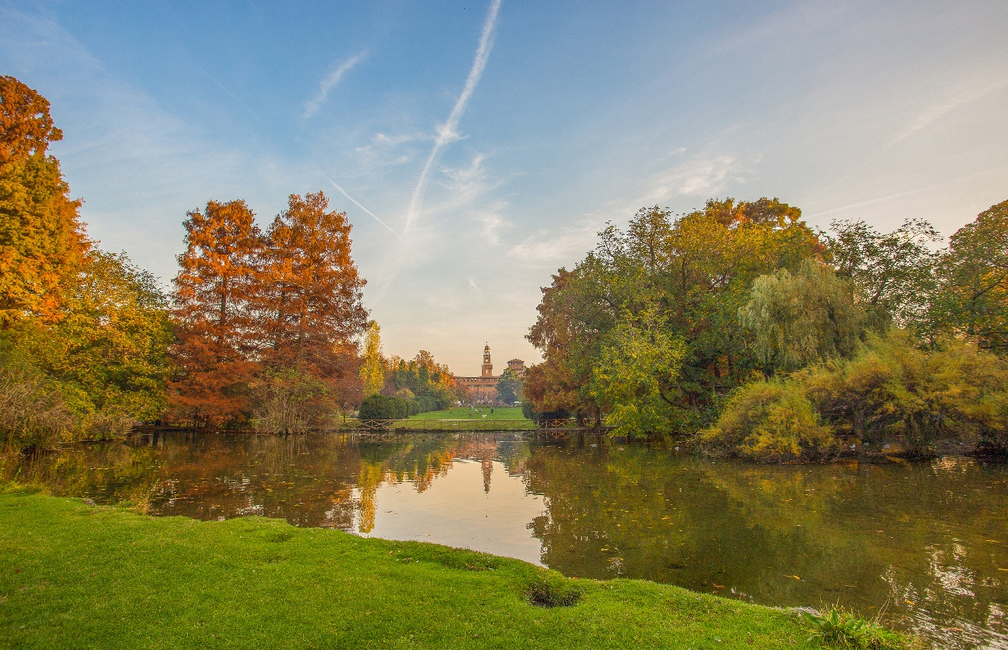
Figure 1: As Table 1 stated, you are welcome to include Tables and Figures. All Figures must have Alt Text.

Chapter Title
Lorem ipsum dolor sit amet, consectetuer adipiscing elit. Aenean commodo ligula eget dolor. Aenean massa. Cum sociis natoque penatibus et magnis dis parturient montes, nascetur ridiculus mus. Donec quam felis, ultricies nec, pellentesque eu, pretium quis, sem. Nulla consequat massa quis enim. Donec pede justo, fringilla vel, aliquet nec, vulputate eget, arcu. In enim justo, rhoncus ut, imperdiet a, venenatis vitae, justo. Nullam dictum felis eu pede mollis pretium. Integer tincidunt. Cras dapibus. Vivamus elementum semper nisi. Lorem ipsum dolor sit amet, consectetuer adipiscing elit. Aenean commodo ligula eget dolor. Aenean massa. Cum sociis natoque penatibus et magnis dis parturient montes, nascetur ridiculus mus. Donec quam felis, ultricies nec, pellentesque eu, pretium quis, sem. Nulla consequat massa quis enim. Donec pede justo, fringilla vel, aliquet nec, vulputate eget, arcu. In enim justo, rhoncus ut, imperdiet a, venenatis vitae, justo. Nullam dictum felis eu pede mollis pretium. Integer tincidunt. Cras dapibus. Vivamus elementum semper nisi.

Table 2: We inserted a Page Break before the caption to prevent the Table from breaking awkwardly between pages. That is an optional step, and you are not required to do it. Please see Tables 3 and 4 to see the result of NOT inserting a Page Break. If you need assistance with this issue, please contact the UDTS Coordinator: udts@gmu.edu. All Tables must have header rows.

 | 1 | 2 | 3
Consectetuer
Adipiscing
Elit

Lorem ipsum dolor sit amet, consectetuer adipiscing elit. Aenean commodo ligula eget dolor. Aenean massa. Cum sociis natoque penatibus et magnis dis parturient montes, nascetur ridiculus mus. Donec quam felis, ultricies nec, pellentesque eu, pretium quis, sem. Nulla consequat massa quis enim. Donec pede justo, fringilla vel, aliquet nec, vulputate eget, arcu. In enim justo, rhoncus ut, imperdiet a, venenatis vitae, justo. Nullam dictum felis eu pede mollis pretium. Integer tincidunt. Cras dapibus. Vivamus elementum semper nisi.

Table 3: You are permitted to use color in Tables and Figures. Your captions can be as long as you wish, but you do not have to include all of the caption’s text in the List of Tables or List of Figures (although you are welcome to do so if you wish). All Tables must have header rows.

 | Γ | Δ | Θ | Λ | Ξ
Aenean
Commodo
Ligula
Eget
Dolor
Sociis
Natoque

A Subsection
Lorem ipsum dolor sit amet, consectetuer adipiscing elit. Aenean commodo ligula eget dolor. Aenean massa. Cum sociis natoque penatibus et magnis dis parturient montes, nascetur ridiculus mus. Donec quam felis, ultricies nec, pellentesque eu, pretium quis, sem. Nulla consequat massa quis enim. Donec pede justo, fringilla vel, aliquet nec, vulputate eget, arcu. In enim justo, rhoncus ut, imperdiet a, venenatis vitae, justo. Nullam dictum felis eu pede mollis pretium. Integer tincidunt. Cras dapibus. Vivamus elementum semper nisi.

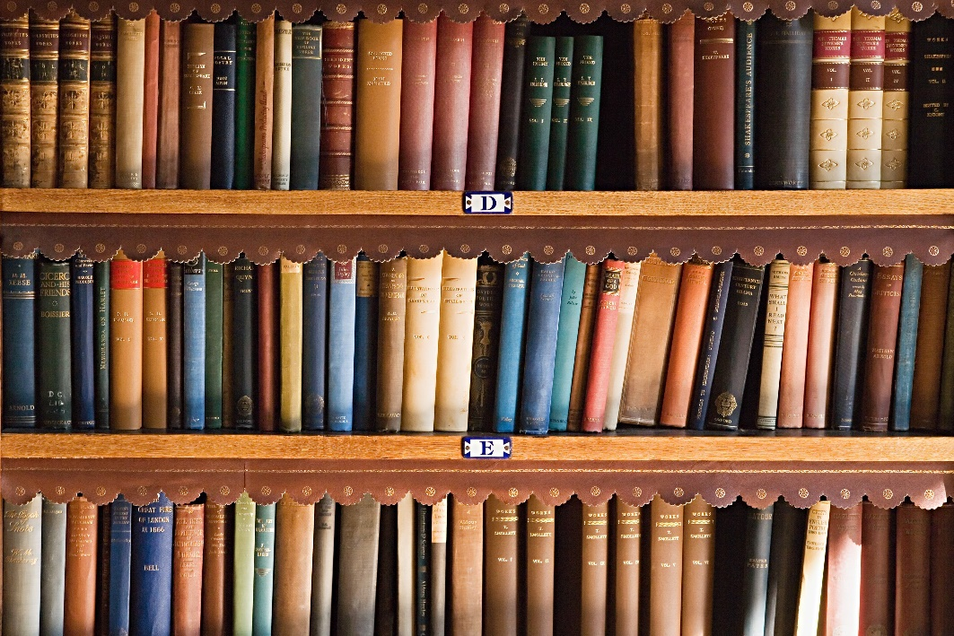
Figure 2: An example of a library. Please note that Tables and Figures (and their accompanying captions) must be separated from nearby lines of body text by at least 3 single-spaced blank lines above and below. You may have more space, but you may not have less. All Figures must have Alt Text.

Another Subsection
Lorem ipsum dolor sit amet, consectetuer adipiscing elit. Aenean commodo ligula eget dolor. Aenean massa. Cum sociis natoque penatibus et magnis dis parturient montes, nascetur ridiculus mus. Donec quam felis, ultricies nec, pellentesque eu, pretium quis, sem. Nulla consequat massa quis enim. Donec pede justo, fringilla vel, aliquet nec, vulputate eget, arcu. In enim justo, rhoncus ut, imperdiet a, venenatis vitae, justo. Nullam dictum felis eu pede mollis pretium. Integer tincidunt. Cras dapibus. Vivamus elementum semper nisi.
Lorem ipsum dolor sit amet, consectetuer adipiscing elit. Aenean commodo ligula eget dolor. Aenean massa. Cum sociis natoque penatibus et magnis dis parturient montes, nascetur ridiculus mus. Donec quam felis, ultricies nec, pellentesque eu, pretium quis, sem. Nulla consequat massa quis enim. Donec pede justo, fringilla vel, aliquet nec, vulputate eget, arcu. In enim justo, rhoncus ut, imperdiet a, venenatis vitae, justo. Nullam dictum felis eu pede mollis pretium. Integer tincidunt. Cras dapibus. Vivamus elementum semper nisi.
A sub-subsection. Lorem ipsum dolor sit amet, consectetuer adipiscing elit. Aenean commodo ligula eget dolor. Aenean massa. Cum sociis natoque penatibus et magnis dis parturient montes, nascetur ridiculus mus. Donec quam felis, ultricies nec, pellentesque eu, pretium quis, sem. Nulla consequat massa quis enim. Donec pede justo, fringilla vel, aliquet nec, vulputate eget, arcu. In enim justo, rhoncus ut, imperdiet a, venenatis vitae, justo. Nullam dictum felis eu pede mollis pretium. Integer tincidunt. Cras dapibus. Vivamus elementum semper nisi.
A sub-sub-subsection. Lorem ipsum dolor sit amet, consectetuer adipiscing elit. Aenean commodo ligula eget dolor. Aenean massa. Cum sociis natoque penatibus et magnis dis parturient montes, nascetur ridiculus mus. Donec quam felis, ultricies nec, pellentesque eu, pretium quis, sem. Nulla consequat massa quis enim. Donec pede justo, fringilla vel, aliquet nec, vulputate eget, arcu. In enim justo, rhoncus ut, imperdiet a, venenatis vitae, justo. Nullam dictum felis eu pede mollis pretium. Integer tincidunt. Cras dapibus. Vivamus elementum semper nisi.

Equation 1: Captions for Equations can be above the Equation, below the Equation, or to the side of the Equation. To learn more about placing the caption to the side of the Equation, please set up an appointment with the UDTS Coordinator: https://gmu.libcal.com/appointments?u=6908.
$$f\left(x\right)=a_{0}+\sum_{n=1}^{∞}{\left(a_{n}\cos{\frac{nπx}{L}}+b_{n}\sin{\frac{nπx}{L}}\right)}$$

Chapter Title
Lorem ipsum dolor sit amet, consectetuer adipiscing elit. Aenean commodo ligula eget dolor. Aenean massa. Cum sociis natoque penatibus et magnis dis parturient montes, nascetur ridiculus mus. Donec quam felis, ultricies nec, pellentesque eu, pretium quis, sem. Nulla consequat massa quis enim. Donec pede justo, fringilla vel, aliquet nec, vulputate eget, arcu. In enim justo, rhoncus ut, imperdiet a, venenatis vitae, justo. Nullam dictum felis eu pede mollis pretium. Integer tincidunt. Cras dapibus. Vivamus elementum semper nisi.

Table 4: This Table came from an Excel spreadsheet. There is no Page Break above the caption, but one could be inserted if you wish. All Tables must have header rows.
 | Ichi | Ni | San | Shi | Go
Edu | 12/2/2022 | 1/6/2023 | Yes | 1/5/2023 | 1/6/2023
ESPP | 8/18/2022 | 8/29/2022 | Yes | 8/17/2022 | 8/29/2022
Edu | 11/7/2022 | 11/18/2022 | Yes | 11/16/2022 | 11/18/2022
PubPol | 11/18/2022 | 11/22/2022 | Yes
Edu | 1/23/2023 | 1/31/2023 | Yes
BioEng | 12/5/2022 | 1/6/2023 | Yes | 12/9/2022 | 1/6/2023
BioInfo | 10/14/2022 | 1/6/2023 | Yes | 12/14/2022
PubPol | 1/17/2023 | 1/19/2023 | Yes | 1/19/2023 | 1/19/2023
CSI | 1/3/2023 | 1/13/2023 | Yes | 1/10/2023 | 1/13/2023
Bio | 10/20/2022 | 11/30/2022 | Yes | 1/3/2022 | 11/30/2022
BioSci | 1/9/2023 | 1/13/2023 | Yes
PubPol | 4/19/2022 | 4/27/2022 | Yes | 4/25/2022 | 4/27/2022
Bio | 11/21/2022 | 11/27/2022 | Yes
IT | 11/22/2022 | 1/19/2023 | Yes | 1/17/2023 | 1/13/2023
ESP | 11/28/2022 | 1/20/2023 | Yes | 1/20/2023 | 1/20/2023
CAR | 1/24/2023 | 1/31/2023 | Yes
BioInfo | 10/20/2022 | 11/30/2022 | Yes | 11/29/2022 | 11/30/2022

A Section
Lorem ipsum dolor sit amet, consectetuer adipiscing elit. Aenean commodo ligula eget dolor. Aenean massa. Cum sociis natoque penatibus et magnis dis parturient montes, nascetur ridiculus mus. Donec quam felis, ultricies nec, pellentesque eu, pretium quis, sem. Nulla consequat massa quis enim. Donec pede justo, fringilla vel, aliquet nec, vulputate eget, arcu. In enim justo, rhoncus ut, imperdiet a, venenatis vitae, justo. Nullam dictum felis eu pede mollis pretium. Integer tincidunt. Cras dapibus. Vivamus elementum semper nisi.

A Subsection
Lorem ipsum dolor sit amet, consectetuer adipiscing elit. Aenean commodo ligula eget dolor. Aenean massa. Cum sociis natoque penatibus et magnis dis parturient montes, nascetur ridiculus mus. Donec quam felis, ultricies nec, pellentesque eu, pretium quis, sem. Nulla consequat massa quis enim. Donec pede justo, fringilla vel, aliquet nec, vulputate eget, arcu. In enim justo, rhoncus ut, imperdiet a, venenatis vitae, justo. Nullam dictum felis eu pede mollis pretium. Integer tincidunt. Cras dapibus. Vivamus elementum semper nisi.

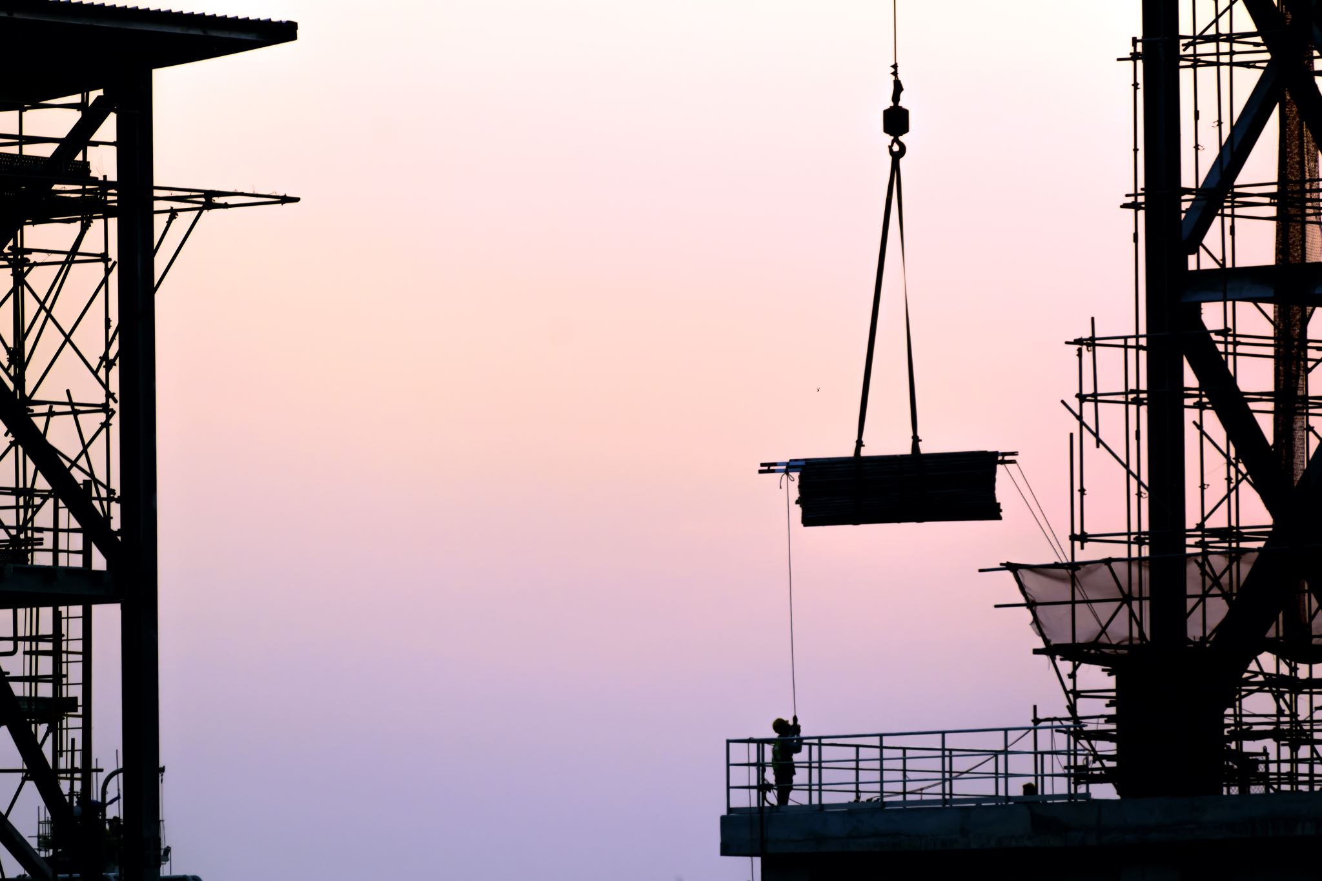
Figure 3: A construction site. Your captions can be as long as you wish, but you do not have to include all of the caption’s text in the List of Tables or List of Figures (although you are welcome to do so if you wish). If you need assistance with this issue, please contact the UDTS Coordinator: udts@gmu.edu. All Figures must have Alt Text.

A Sub-Subsection. Lorem ipsum dolor sit amet, consectetuer adipiscing elit. Aenean commodo ligula eget dolor. Aenean massa. Cum sociis natoque penatibus et magnis dis parturient montes, nascetur ridiculus mus. Donec quam felis, ultricies nec, pellentesque eu, pretium quis, sem. Nulla consequat massa quis enim. Donec pede justo, fringilla vel, aliquet nec, vulputate eget, arcu. In enim justo, rhoncus ut, imperdiet a, venenatis vitae, justo. Nullam dictum felis eu pede mollis pretium. Integer tincidunt. Cras dapibus. Vivamus elementum semper nisi.

Chapter Title
Lorem ipsum dolor sit amet, consectetuer adipiscing elit. Aenean commodo ligula eget dolor. Aenean massa. Cum sociis natoque penatibus et magnis dis parturient montes, nascetur ridiculus mus. Donec quam felis, ultricies nec, pellentesque eu, pretium quis, sem. Nulla consequat massa quis enim. Donec pede justo, fringilla vel, aliquet nec, vulputate eget, arcu. In enim justo, rhoncus ut, imperdiet a, venenatis vitae, justo. Nullam dictum felis eu pede mollis pretium. Integer tincidunt. Cras dapibus. Vivamus elementum semper nisi.

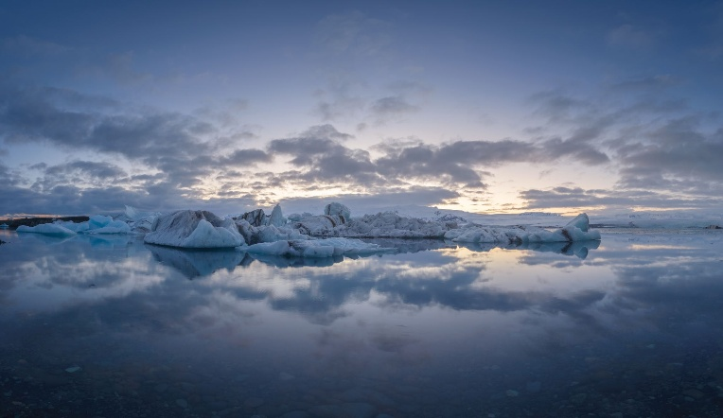

Figure 4: Tables and Figures can be centered, if you wish. All Figures must have Alt Text.

Table 5: We don’t have rules for spacing between series of Tables, series of Figures, or a mixed series of Tables and Figures. Spacing rules only apply to Tables and Figures in relation to body text. All Tables must have header rows.
 | Uno | Dos | Tres | Cuatro | Cinco | Seis
Penatibus
Et
Magnis
Di
Parturient

Lorem ipsum dolor sit amet, consectetuer adipiscing elit. Aenean commodo ligula eget dolor. Aenean massa. Cum sociis natoque penatibus et magnis dis parturient montes, nascetur ridiculus mus. Donec quam felis, ultricies nec, pellentesque eu, pretium quis, sem. Nulla consequat massa quis enim. Donec pede justo, fringilla vel, aliquet nec, vulputate eget, arcu. In enim justo, rhoncus ut, imperdiet a, venenatis vitae, justo. Nullam dictum felis eu pede mollis pretium. Integer tincidunt. Cras dapibus. Vivamus elementum semper nisi.

Appendices
Appendix Title Here

References/Bibliography/Works Cited
Alliance for Excellent Education. (2012). Culture shift: Teaching in a learner centered environment empowered by digital learning. Retrieved from the Alliance for Excellent Education website http://www.all4ed.org/files/CultureShift.pdf

Abrams, L. M., Pedulla, J. J., & Madaus, G. F. (2003). Views from the classroom: Teachers’ opinions of statewide testing programs. Theory Into Practice, 42(1), 18–29. https://doi.org/10.1207/s15430421tip4201_4

Au, W. (2007). High stakes testing and curricular control: A qualitative metasynthesis. Educational Researcher, 36, 258–267. https://doi.org/10.3102/0013189X07306523

Berry, B., & Eckert, J. (2012). Creating teacher incentives for school excellence and equity. Retrieved from the National Education Policy Center website http://nepc.colorado.edu/editorial-board

Billingsley, B. S. (1993). Teacher retention and attrition in special and general education: A critical review of the literature. The Journal of Special Education, 27, 137–174. https://doi.org/10.1177/002246699302700202

Creswell, J. W. (2013). Qualitative inquiry and research design. Sage.

Kersaint, G., Lewis, J., Potter, R., & Meisels, G. (2007). Why teachers leave: Factors that influence retention and resignation. Teaching and Teacher Education, 23, 775–794. https://doi.org/10.1016/j.tate.2005.12.004

Lamonte, K. M. (2011). Examining the factors involved in a teacher’s decision to remain in the teaching profession. Retrieved from ProQuest Digital Dissertations. (AAT 9102569)

Biography
Your Name must include this page in the Thesis/Dissertation. What information you include is up to you, and you may include as little or as much information as you wish, but you must include this page.

